**Fractional Zero**

Fractional zero transfer function is given by $T(s$) = $s^{α}+a$…... (1)

Put s = jω, in equation (1) results into $T(jω$) = $({jω)}^{α}+a$…… (2)

Magnitude in dB is given by |) | dB = 20log ( $\sqrt{a^{2}+ω^{2α}+2{aω}^{α}\cos{\frac{πα}{2}}}$)

**Calculation procedure**

$({jω)}^{α}$

= $({0+1j)}^{α}$ = ${\text{(cos}\frac{π}{2}+j\text{sin }\frac{π}{2}\text{)} }^{α}ω^{α}$

Applying De Moivre’s theorem in above equation we get

= $\text{(cos}\frac{απ}{2}+j\text{sin }\frac{απ}{2}\text{)}ω^{α}$…… (3)

Put equation (3) in (2) we get

$T(jω$) = $\text{(cos}\frac{απ}{2}+j\text{sin }\frac{απ}{2}\text{)}ω^{α}$ +a

= $\text{(}ω^{α}\text{cos}\frac{απ}{2}+a)$ + $jω^{α}\text{sin }\frac{απ}{2}$

Magnitude, |) | =

=

Now, Magnitude in dB, |) | dB = 20log ${\text{(}ω^{2α}\text{+ }a^{2}\text{+ }2ω^{α}a\text{cos}\frac{απ}{2}\text{)}}^{\frac{1}{2}}$

In the sum ${(ω}^{2α}\text{+ }a^{2}\text{+ }2ω^{α}a\text{cos}\frac{απ}{2}$), $a^{2}$ dominates at lower frequencies whereas $ω^{2α}$ dominates at higher frequencies.

For approximation we consider $a^{2}$ = $ω^{2α}|_{ω=ω_{cr}}$.We obtain corner frequency at $ω_{cr}$ = ${|a|}^{\frac{1}{α}}$.

Now, following approximation of magnitude is obtained:

1. For ω ≤ , |) | dB = 20log ${(a^{2})}^{\frac{1}{2}}$ = 20log|a|.
2. For ω >, |) | dB = 20log ${(ω^{2α})}^{\frac{1}{2}}$ = 20αlog ω.

**Procedure**

* Compute the corner frequency $ω_{cr}$ = ${|a|}^{\frac{1}{α}}$ and locate the point at magnitude 20log|a|.
* Draw a slope 0 dB/decade for ω ≤ $ω_{cr}$ and a line with slope 20α dB/decade for ω> $ω_{cr}.$

**Results**: Taking α = 0.8, a = 3 and $ω_{cr}=$ 3.948.

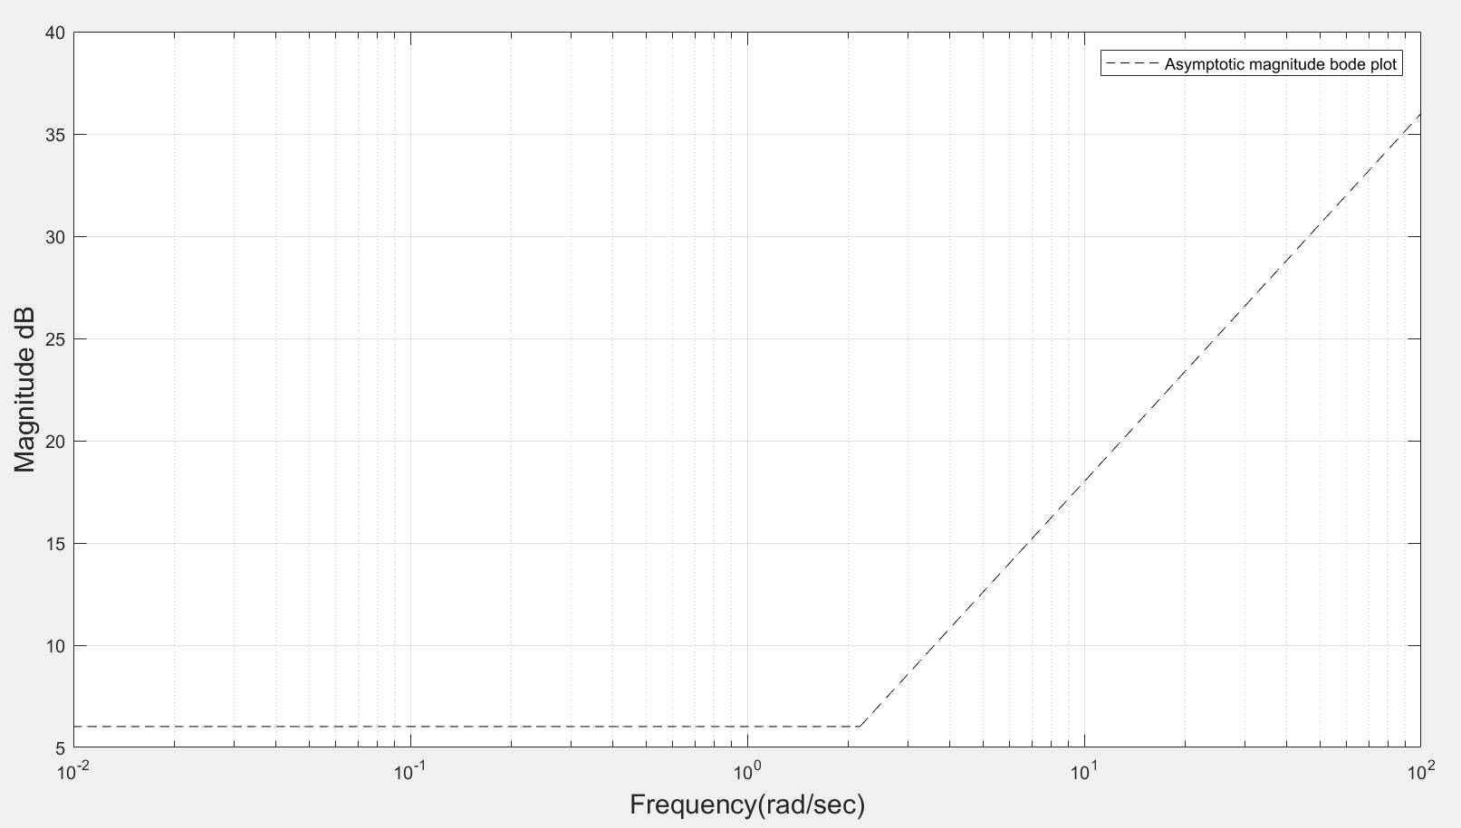

**Figure 3.2-Asymptotic magnitude bode plot of fractional zero**

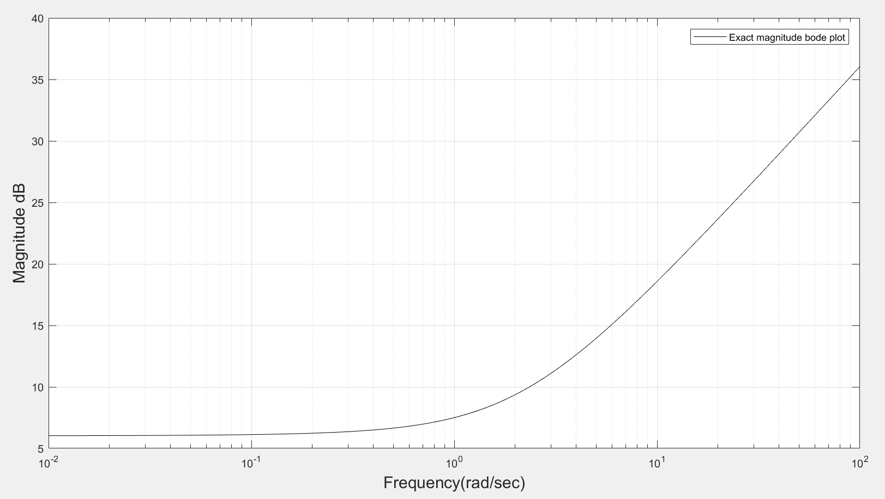

**Figure 3.3-Exact magnitude bode plot for fractional zero.**

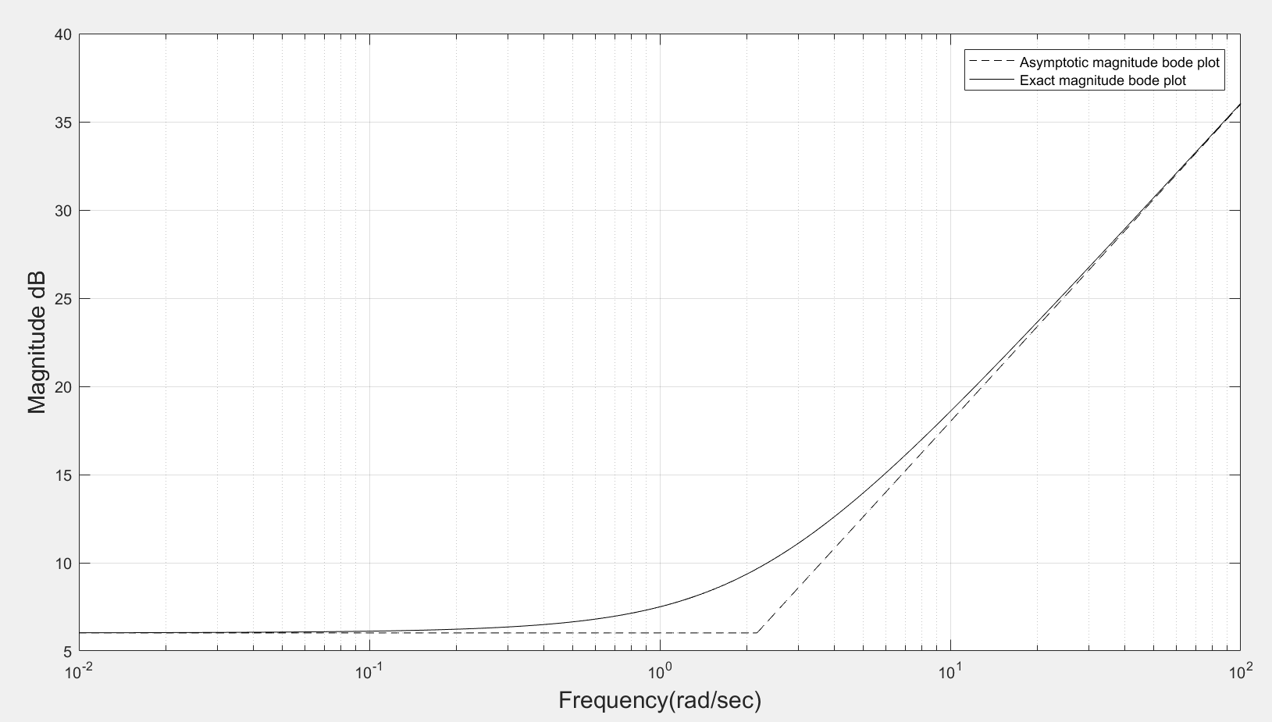

**Figure 3.4-Asymptotic and exact magnitude bode plot for fractional zero**